Assignment 2 – Result Analysis

1. K-Gram Construction and Jaccard Similarity
In this task, different types of k-grams were generated from the four documents in order to analyse their similarity. Character-based 2-grams, character-based 3-grams, and word-based 2-grams were constructed while ensuring that duplicate k-grams were ignored.
The computed Jaccard similarities show clear differences depending on the representation used. For character 2-grams, the similarity between D1 and D2 was very high (0.981), indicating that the two documents share a large number of overlapping character patterns. Similarly, D1 and D3 (0.816) and D2 and D3 (0.800) also show relatively strong similarity. In contrast, pairs involving D4 show lower similarity values, such as D1–D4 (0.644) and D2–D4 (0.641), suggesting that this document differs more significantly in its structure.
When character 3-grams were used, the similarity values decreased for most document pairs. For example, D1–D3 dropped to 0.580, while D1–D4 and D2–D4 were around 0.305. This reduction is expected because longer k-grams capture more detailed patterns, making the similarity measure stricter.
Overall, these results illustrate that smaller k values tend to produce higher similarity estimates, while larger k values provide a more precise but stricter comparison between documents.
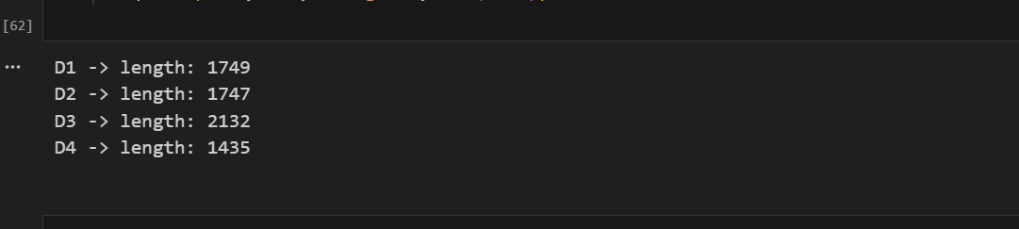

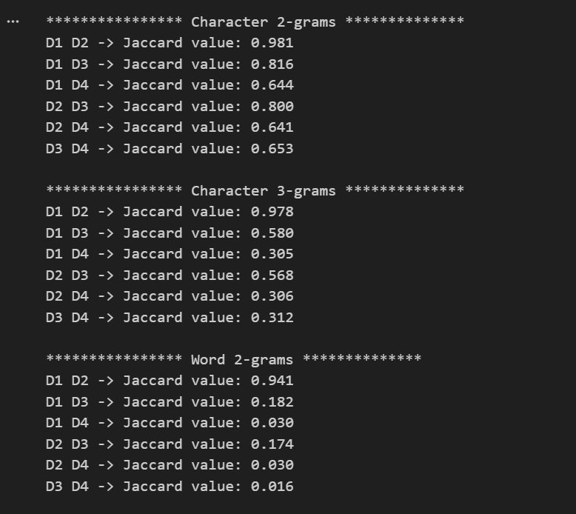

2. Min-Hashing
A. Approximate Jaccard Similarity
Min-hashing was applied using 3-gram representations of documents D1 and D2. The exact Jaccard similarity between the two documents was 0.978. The approximate similarities obtained using different numbers of hash functions were:
t (hash functions) | Estimated Similarity
20 | 0.950
60 | 0.983
150 | 0.987
300 | 0.973
600 | 0.982
The estimates remain close to the true similarity value even for relatively small values of t. With t = 20, the estimate is slightly lower than the exact similarity, which is expected due to higher variance. As the number of hash functions increases, the estimates become more stable and closer to the true value.
This experiment confirms the theoretical property of Min-Hashing: the probability of signature agreement approximates the true Jaccard similarity.
B. Choosing a Good Value for t
Based on the experiments, t = 150 or t = 300 appears to provide a good balance between computational efficiency and accuracy. At t = 150, the estimated similarity (0.987) is already extremely close to the true value (0.978). Increasing the number of hash functions beyond this point provides only marginal improvements while increasing computational cost.
Therefore, using around 150 hash functions offers a practical compromise between accuracy and performance.

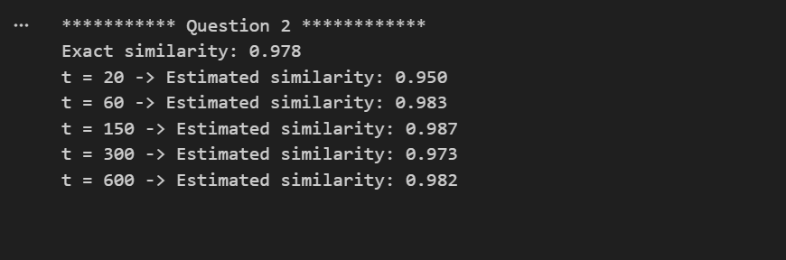

3. Locality Sensitive Hashing (LSH)
A. Choice of Parameters (r, b)
For LSH, the signature size was t = 160. To create an appropriate S-curve around the threshold τ = 0.7, the signature was divided into b = 20 bands with r = 8 rows per band.
Using the probability function
f(s)=1−(1−sb)rf(s) = 1 - (1 - s^b)^rf(s)=1−(1−sb)r
this configuration produces a strong separation around the similarity threshold, ensuring that document pairs with similarity above the threshold are likely to be identified as candidate pairs.

B. Probability of Candidate Pairs
Using the chosen configuration (r = 8, b = 20), the probability that each document pair will be considered a candidate pair was computed as follows:
Document Pair | Probability
D1 – D2 | 1.000
D1 – D3 | 0.228
D1 – D4 | 0.001
D2 – D3 | 0.196
D2 – D4 | 0.002
D3 – D4 | 0.002
The results clearly show that D1 and D2 have a probability of 1.0, meaning they are almost certainly detected as a similar pair. This aligns with the very high similarity observed earlier. Other pairs have much lower probabilities, indicating that LSH successfully separates highly similar documents from less similar ones.

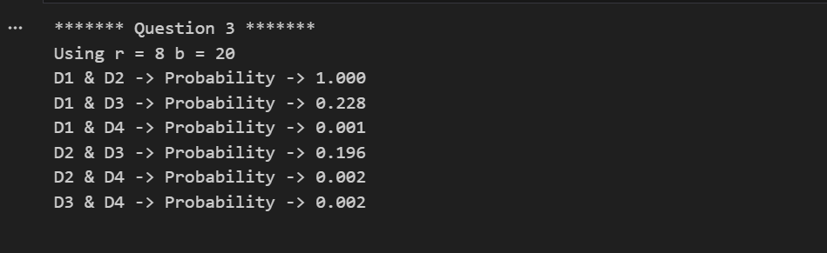

4. Min-Hashing on the MovieLens Dataset
In this experiment, Min-Hashing was applied to the MovieLens 100K dataset in order to approximate Jaccard similarity between users based on the movies they have rated.
The number of user pairs with estimated similarity ≥ 0.5 decreased as the number of hash functions increased:
Hash Functions | Pairs ≥ 0.5
50 | 172
100 | 92
200 | 17
Increasing the number of hash functions improved the quality of the approximation.
The average number of errors across five runs was:
Hash Functions | False Positives | False Negatives
50 | 118.8 | 3.4
100 | 24.2 | 2.6
200 | 9.8 | 2.0
These results show that larger signatures significantly reduce false positives, while false negatives remain relatively low. This demonstrates that increasing the number of hash functions improves the reliability of similarity estimation.
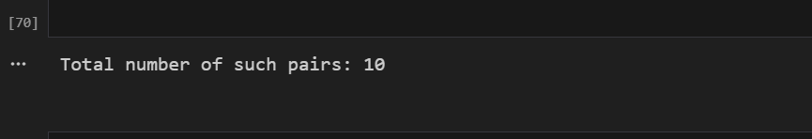
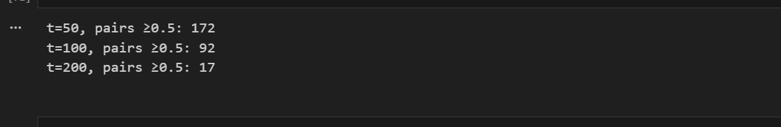

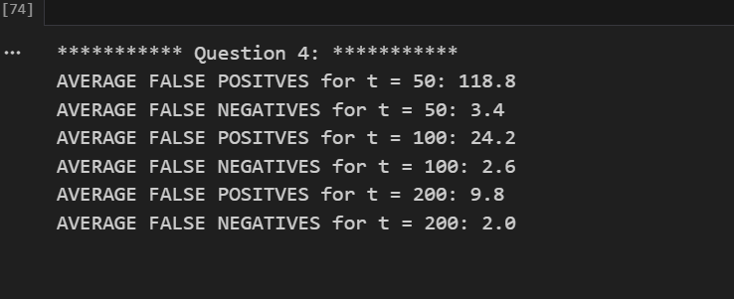

5. LSH on the MovieLens Dataset
Locality Sensitive Hashing was applied to identify candidate user pairs with high similarity. Different band configurations were tested using signature tables of different sizes.
The experiments show that LSH generates a large number of candidate pairs while maintaining very low false negatives. For example, with threshold 0.6, the system produced zero false negatives across runs, meaning that all truly similar pairs were successfully retrieved.
However, the number of false positives remained relatively high, particularly for lower thresholds. Increasing the similarity threshold to 0.8 slightly increased the number of false positives, but the overall behavior remained similar.
These results highlight the typical trade-off of LSH: it is extremely effective at avoiding false negatives and identifying potential similar pairs quickly, but it may return additional candidate pairs that require further verification.

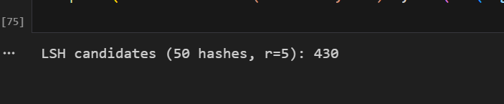







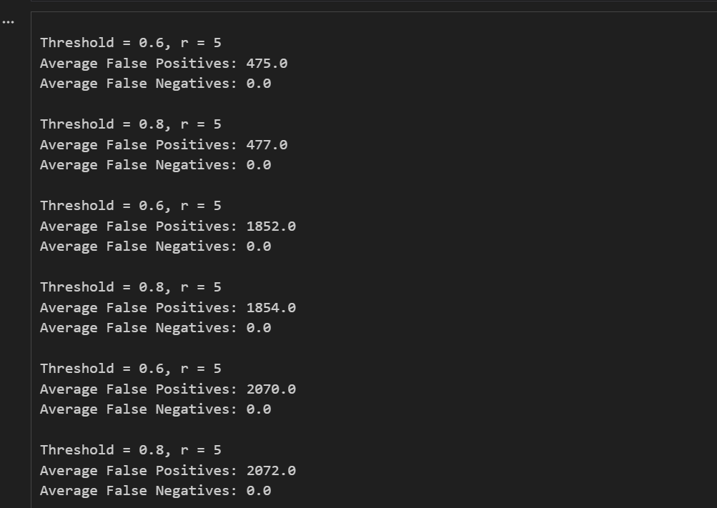

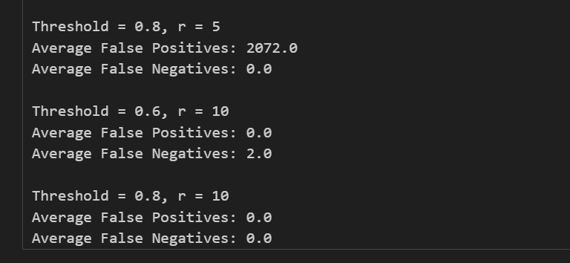

Graph Analysis

1. False Positives vs Similarity Threshold
The first graph illustrates how the number of false positives varies with different MinHash signature sizes and LSH configurations when the similarity threshold changes from 0.6 to 0.8. It can be observed that configurations with smaller signature sizes (50 and 100 hash functions) generate fewer candidate pairs but still produce a noticeable number of false positives. In particular, the configuration with 100 hash functions produces the largest number of false positives, followed by the configuration with 200 hash functions and r = 5.
An interesting observation is that the configuration 200 hash functions with r = 10 produces almost zero false positives, indicating that increasing the number of rows per band makes the similarity requirement stricter. As a result, only document pairs with very strong similarity are selected as candidates. Overall, the graph highlights the trade-off between sensitivity and precision: configurations with fewer rows per band tend to generate more candidate pairs, while stricter configurations significantly reduce incorrect matches.
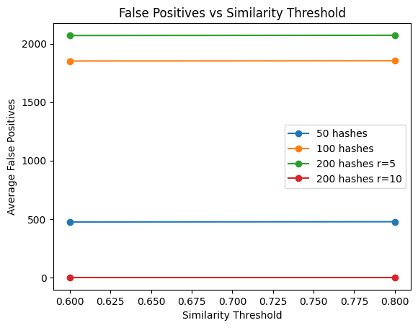

2. False Negatives vs Similarity Threshold
The second graph shows the variation in false negatives when the similarity threshold increases from 0.6 to 0.8. For most configurations, including 50 hashes, 100 hashes, and 200 hashes with r = 5, the number of false negatives remains zero across both thresholds, indicating that these configurations are able to capture all highly similar pairs effectively.
However, the configuration 200 hashes with r = 10 initially produces two false negatives at the threshold of 0.6, meaning that some genuinely similar pairs were not detected as candidates. When the threshold increases to 0.8, the number of false negatives drops to zero, suggesting that the stricter similarity requirement aligns better with the LSH configuration.
These results demonstrate that while stricter banding parameters can reduce false positives, they may also increase the risk of missing some similar pairs. Therefore, selecting appropriate values of r and b is important to balance detection accuracy and efficiency.

